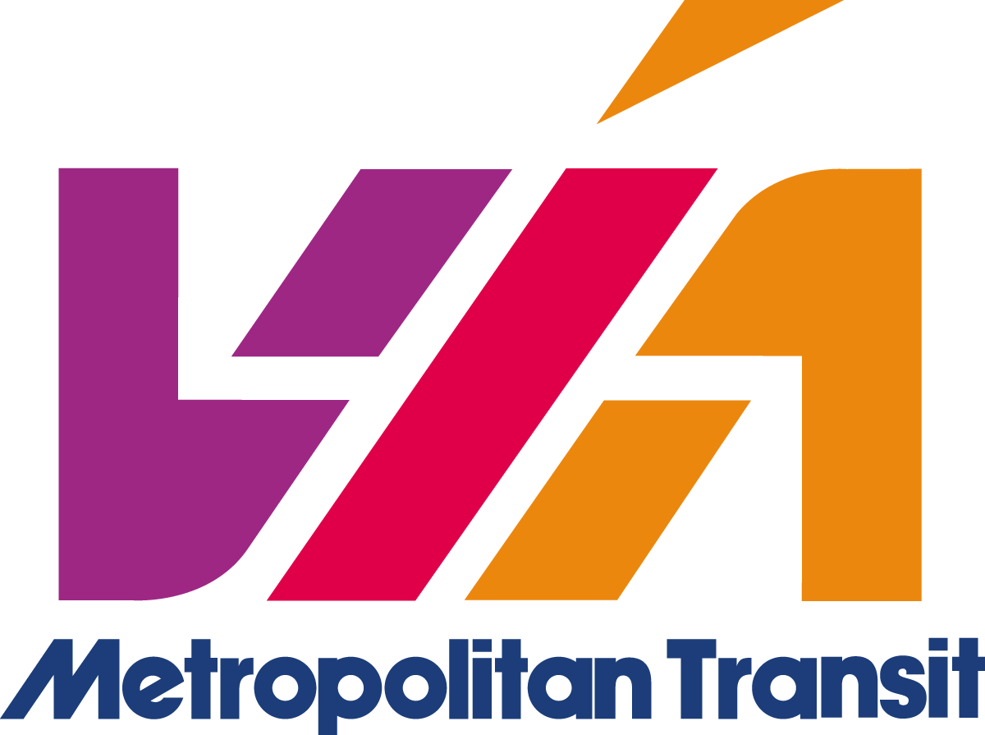

Program Management Plan
Section 5310
ENHANCED MOBILITY OF SENIORS AND INDIVIDUALS WITH DISABILITIES PROGRAM
Table of Contents
Goals and Objectives 3
Roles and Responsibilities of VIA 3
Alamo Area Regional Public Transportation Coordination Plan 3
Eligible Sub-recipients 4
Funding Eligibility 4
Local Funding Requirements 5
Funding Distribution and Project Selection Criteria 6
Application Cycle 6
Application, Evaluation and Scoring 6
Equity of Distribution 6
Project Approval and Award 6
Timeline 7
Sub-recipients Monitoring 8
Administration of 5310 Programs 8
Title VI, Section 504, and ADA Compliance 9
Management of 5310 Programs 10
Performance Measures 11
Program Management Plan Updates 11

PROGRAM MANAGEMENT PLAN

Goals and Objectives
The goal of this Program Management Plan (PMP) is to describe VIA Metropolitan Transit’s process for managing the Federal Transit Administration (FTA) 5310 program within the San Antonio urbanized area. As part of this process, VIA intends to fulfill the following objectives:

- Identify, contact and inform public agencies, community organizations, non-profit and private for profit organizations providing service for seniors and persons with disabilities, as to the availability of 5310 program grant funds;
- Establish, promote and outline processes for soliciting and evaluating 5310 program funding proposals;
- Assure that proposals selected for funding are responsive to one or more of the needs identifies in the Alamo Area Regional Public Transportation Coordination Plan;
- Establish the requirements for the selected projects to enter into grant agreements with VIA; and,
- Summarize the requirements for managing and reporting the progress for implementing the funded projects.

This PMP is a living document. It will be updated as necessary to incorporate any expansions and enhancements of the 5310 program, as well as any revisions to the programs’ management, requirements or guidelines.

Roles and Responsibilities of VIA
VIA is the Designated Recipient for 5310 funds allocated to the San Antonio urbanized area. VIA’s role includes administering, managing and programming these funds, and selecting and monitoring the implementation of funded projects. VIA also has a responsibility to announce a call-for-projects and provide technical assistance in the completion of grant applications. Moreover, it is VIA’s responsibility to ensure that all interested parties have a fair and equitable opportunity to apply; and if selected, receive a fair and equitable distribution of funds. Once funds are distributed, VIA is to ensure that all selected grant recipients comply with guidelines as defined by the FTA and any state or local authority. Other VIA responsibilities (as the Designated Recipient) of funds from the 5310 program is relevant to the Alamo Area Regional Public Transportation Coordination Plan and is briefly described below.

Alamo Area Regional Public Transportation Coordination Plan
This plan, developed and maintained by the Alamo Area Council of Governments (AACOG), lays out various recommended approaches for maximizing the potential benefits that can be derived through the coordination of services. VIA also emphasized the coordination of services among the region’s stakeholders and eligible sub- recipients of funding from the 5310 programs. Accordingly, applicants must describe their project level coordination arrangements prior to being considered for grant funding. VIA also encourages the efforts of the region’s stakeholders to streamline arrangements prior to being considered for grant funding and expand the eligibility of projects and services that could be funded by the 5310 programs.

VIA will support coordination by:

- Announcing a call-for-projects through local media, local newspapers, the VIA website and other media, to increase awareness and understanding of the 5310 program;
- Designing and implementing an inclusive selection process;
- Involving a small group of stakeholders or service recipients to review and provide feedback on the applications (if required);
- Providing technical assistance to applicants and sub-recipients; and
- Remaining in regular contact with the FTA and providing timely reports as determined by FTA guidance.

Although VIA is not directly responsible for developing the Alamo Area Regional Public Transportation Coordination Plan, VIA’s project review and selection process will include a determination that sub-recipient projects are consistent with the plan.

Eligible Sub-recipients
Under the federal guidelines, the following entities are eligible to apply for 5310 funding:

- Local governmental agencies
- Public and private transportation providers
- Social service agencies
- Tribal governments
- Non-profit organizations

To be eligible for funding from the 5310 programs, proposed projects must be located or either have an origin or a destination within the San Antonio urbanized area.

Funding Eligibility
Section 5310 funds are available for capital and operating expenses to support the provision of transportation services that meet the specific needs of seniors and individuals with disabilities.

Capital
55 percent of funds shall be available for capital projects planned, designed, and carried out to meet the needs of seniors and people with disabilities. 55 percent is a floor, not a ceiling; more than 55 percent of apportionments can be used for these types of projects.

Eligible projects for the required 55 percent of capital projects include the capital cost of contracting for the provision of transit services for seniors and individuals with disabilities and other specialized shared-ride transportation services. The purchase of rolling stock for or the acquisition of ADA complementary paratransit service are eligible capital expenses that may also qualify under the 5310 program as public transportation capital projects planned, designed and carried out to meet the specific needs of seniors and individuals with disabilities when fixed-route public transportation is insufficient, unavailable or inappropriate, provided the projects are carried out by eligible sub-recipients.

Operating
45 percent of 5310 funds may be used for operating expenses that provide transportation services that exceed the requirements of the ADA or improve access to fixed route services and decrease reliance by individuals with disabilities on ADA complementary paratransit service.

Local Funding (Match) Requirements
5310 funds are eligible to support up to 80 percent of the cost of capital projects and up to 50 percent of the net operating costs.

The local share may be provided from an undistributed cash surplus, a replacement or depreciation cash fund, reserve, and a service agreement with a state or local service agency, private social service organization or new capital. Some examples of these sources of local match include:

- State or local appropriations
- Dedicated tax revenues
- Private donations
- Revenue from service contracts
- Transportation Development Credits (TDCs)
- Net income generated from advertising and concessions
Non-cash share:
- Donations
- Volunteered services
- In-kind contributions are accepted with respect to the following:
- Eligible to be counted toward local match as long as the value of each is documented and supported;
- represents a capital cost which would otherwise be eligible under the program;
- and included in the net project cost in the project budget.

The source(s) of local funding must be identified in the initial 5310 grant application. The use and certification of Transportation Development Credits (TDCs) is the sole responsibility of the sub-recipient in most cases. TDC Certification documentation must be provided to VIA and VIA must include the documentation in the FTA TEAM grant application. VIA will assist sub-recipients in obtaining the TDC Certification documentation from the Texas Department of Transportation (TxDOT) and act in behalf of the sub-recipient when TDCs are requested.

Funding Distribution and Project Selection Criteria

Application Cycle
MAP-21 requires that projects and programs, implemented with 5310 program funding, to be the outcome of a selection process that is fair and equitable. The FTA provides some flexibility with the process itself. The selection process may be held annually or at intervals up to three years, as determined by VIA and based on local needs. VIA will select projects as needed to avoid the lapsing of any funds that are not obligated in a timely manner.

5310 funds need to be obligated within the next two federal fiscal years following the fiscal year in which the funds were appropriated by Congress. In this regard, the federal fiscal year starts on October 1 and ends on September 30 of the following year. Any 5310 funds remaining from prior fiscal year in which the selection will take place and those funds expected to be made available within the following fiscal year. Accordingly, 5310 funds from up to three consecutive fiscal years could be made available and VIA will select projects and programs at intervals not to exceed this time frame. This approach will allow for the development of more viable and longer-term projects, reduce the administrative cost of the programs, and allow for other efficiencies.

Application, Evaluation and Scoring
VIA is responsible for the selection of projects; and could, but is not required to, include a competitive selection process. In any case, VIA will select projects on a fair and equitable basis. If VIA decides to conduct a competitive selection for projects, VIA will conduct the solicitation but retains the option of outsourcing the selection process.

Equity of Distribution
The process for selecting projects will be widely publicized and disseminated directly to the agencies providing or needing specialized transportation services in the San Antonio urbanized area.

Information relevant to the selection process and application guidelines and forms, will be made available at VIA’s website at http://viainfo.net/. As part of the application process, VIA may provide technical assistance to agencies that may not be experienced in the preparation of transportation project proposals, including human service agencies providing or funding client transportation.

Project Approval and Award
Proposals may be selected based on but not limited to project mobility, effectiveness, and benefit to urbanized area, program reach and population served. Once selection of projects and awarding of funds is finalized, VIA staff will submit the list of recommended projects to the VIA Board of Trustees for approval. As the newly designated recipient for 5310, VIA has accepted the FY13 selection process conducted by TxDOT and will honor the awards that went to Kirby Senior Center, PRESA Community Center and St Gregory the Great Catholic Church.

The next step will be to submit the grant TEAM application(s) to the FTA for approval.

Timeline
Award notification for the 5310 programs selected will be transmitted to those agencies. Agencies that were not recommended for funding will be sent letters to inform them of the results of the evaluation process. Sub-recipients recommended for funding will be sent an award notification letter and a Memorandum of Understanding (MOU) between VIA and the sub-recipient will be prepared for execution. The MOU will indicate the date of the grant approval by the FTA and the effective date for project implementation.

Overall, it may take up to 12 months from the announcement date of the call-for-projects to the execution of the MOU. This would depend on funding availability, the number of applications received and the type of selection process. The following is a tentative schedule using a competitive solicitation:

- Solicitation for Proposals: posting information at VIA website, delivering letters to list of agencies on file and conducting additional outreach through local media. It is the responsibility of eligible applicants to keep track of the information posted on VIA’s website and to provide and/or their contact information with VIA.
- Proposals Due: Typically 45 days after release of solicitation for proposals.
- Evaluation of Applications (2 months after proposals are due): VIA may contact the applicant to inquire about the contents of the proposal and may request additional information or clarification. The applicant may also be required to provide an oral presentation of its proposal to the evaluation team.
- Award Notification (1 month after Evaluation of Applications): a letter will be sent to successful applicants with information on the amount and source of the federal award. It will also include a request to confirm the acceptance of the award and the availability and source of the local match in writing.
- FTA Grant Application and Approval (3-5 months after Award Notification): VIA staff will prepare and submit the grant application to the FTA for approval. Due to the certifications needed, including those from the United States Department of Labor, it may take up to two months for FTA’s final approval.
- Memorandum of Understanding (3 months after FTA grant approval): the time required for execution of the MOU between the sub-recipient of funds from the 5310 program and VIA will depend on the availability of supporting documentation from the sub-recipient (such as clear scope of work, timeline for project implementation, project item line budget and cash flow) and its readiness to accept its terms and conditions.
- Effective Date of Reimbursable Activities: the MOU specifies the effective date if its terms and conditions, including the period of reimbursable activities. In this regard, VIA will reimburse the sub-recipient for any eligible expenditure incurred (after deducting the required local match) since the effective date of the MOU. Any expenditure incurred by the sub-recipient prior to the execution of the MOU with VIA is the sub-recipients responsibility.

VIA is not committed to reimburse any expenditure if the MOU between the agencies is ultimately not executed, the project is cancelled, the federal funding is not available, or the FTA does not approve the grant application, among other possible scenarios.

Sub-recipients Monitoring
VIA will coordinate a sub-recipient orientation workshop after the funding award to provide technical assistance on the process that would need to be followed and the federal requirements that would have to be met to receive the federal funds. VIA will also schedule regular meetings with the sub-recipients to discuss issues or concerns regarding their projects and to provide assistance during implementation to ensure projects are consistent with the funding agreement. Sub-recipients will also be required to provide quarterly progress reports and an annual report during the period in which they invoice for eligible activities until grant close-out. In this regard, sub-recipients need to keep track of the performance measures identified for their projects in the MOU.

Sub-recipients would also need to provide supporting documentation when invoicing VIA for expenses incurred. Sub-recipients will not be paid in advance of costs incurred. Instead, funds from the 5310 programs will be paid to the sub-recipient on a reimbursement basis only. VIA will monitor closely all activities by the sub-recipient and take corrective actions to resolve any non-compliance issues, including informing the sub-recipients if they are at risk of losing any of the funding that was awarded. The sub-recipients need also to comply with the auditing requirements specified in the MOU.

Administration of 5310 Programs
The following summarizes the responsibilities of VIA as the designated recipient.
- Assists sub-recipients or potential sub-recipients with technical support to:
- Establish project eligibility;
- Manage and administer sub-recipients;
- Understand grantee (VIA) and federal compliance policies
- Procurement guidelines
- Required matching funds
- Understand the conditions on how federal grant funds can be spent.

One of the primary means of assistance can be sponsoring and hosting pre-proposal seminars prior to call-for-projects. VIA may host a grantee introduction seminar for all new sub-recipients after each selection process. The meeting will allow VIA the opportunity to discuss with all of the new sub-recipients the general and specific performance goals to be achieved, their reporting, the administrative responsibilities and VIA’s standardized invoicing practices.

In order to clarify the goals of each project and assist the sub-recipients in the development of good progress reporting and accounting practices, VIA will meet individually with each of the sub-recipients before the beginning of grant expenditures. The meetings will include, but are not limited to the following actions:

- Ensures that sub-recipients adhere to the FTA Master Agreement, VIA’s MOU, and other federal and state requirements, as applicable, to ensure federal funds are used according to the established contractual requirements. This activity will be accomplished with site visits and review of sub-recipients’ records.
- Seeks from the sub-recipients an annual signed certification that affirms sub-recipients compliance with the standard terms and conditions governing the administration of projects funded with federal dollars awarded by the FTA through VIA, as described on the MOU or the FTA Master Agreement. This information is provided to the auditors as part of VIA’s compliance monitoring effort.
- Provides the program of projects funded with the 5310 program to the MPO for inclusion in the Transportation Improvement Program.
- Prepares a summary of the funds available for distribution upon approval of the federal budget for the federal year that starts October 1, XXXX and corresponding federal transportation appropriations sometime thereafter and their publication in the Federal Register.
- Initiates the development of the grant applications for the FTA and upon FTA’s award, initiates the funding agreements with the sub-recipients.
- Coordinates regular workshops or meetings with sub-recipients to ensure agencies have the technical capabilities to assist their customers with transportation needs and to manage their projects.
- Organizes and annual workshop for the region’s stakeholders to review project results, evaluate overall program accomplishments, and discuss opportunities for improvements. Unsuccessful applicants from previous call-for-projects cycles will also be contacted and invited to the workshop to familiarize themselves with the grant programs, the development of a successful application, and the implementation of projects and programs funded by the 5310 programs. Unsuccessful applicants will also have the opportunity to meet with VIA staff.
- Assures sub-recipients development performance measures for each 5310 funded project to monitor and report the benefits of the federal investment.
- VIA will maintain good working relationship and coordination with the federal, state, regional, and local agencies regarding human services transportation projects and programs funded with the 5310 funds.
- Analyzes federal, state and local legislation and policies relevant to the 5310 program.
- Makes recommendations to the VIA Board of Trustees for improvements in managing and administering the 5310 programs.
- Serves as the point of contact for any activities related to the 5310 programs, such as coordinating the reviews and audits performed by the FTA.

Title VI, Section 504, and ADA Compliance
VIA requires sub-recipients to document that they distribute FTA funds without regard to race, color, national origin, disability or discrimination against disadvantaged business enterprises among applicable civil rights requirements. Not all applicable civil rights requirements are discussed in the PMP.

VIA complies with FTA’s Title VI requirements in the following manner:
- Provision of an annual Title VI certification and assurance;
- Development of Title VI complaint procedures;
- Record keeping of all Title VI investigations, complaints and lawsuits;
- Provision of meaning access to persons with Limited English Proficiency;
- Notification to beneficiaries of protection under Title VI;
- A requirements that each sub-recipient develops a Title VI program or becomes part of VIA’s submittal of its Title VI program to the FTA’s regional civil rights officer once every three years.

Within each of these broad categories are specific requirements for survey and other data collection, analysis and information distribution that cover transportation programs, construction programs, transit service planning, operations and service/fare changes.

VIA’s promotion, administration and distribution of information and funding relevant to the 5310 programs is consistent with IA’s Title VI Policy, which is made part of this document by reference.

In order to fulfill Section 504 obligations, VIA plans on working closely with its sub-recipients to ensure the goals of their federal 5310 grants are being met. In order to track this progress, VIA will review each submitted invoice and insure that all required backup material is attached and correct in order to validate funds spent, work to resolve any potential ineligibility issues with any sub-recipient and obtain the return of any funds paid out that have been found to have been ineligible. In addition, VIA will review all quarterly and annual reports to ensure consistency with the terms of the federal grant and the MOUs. Finally, VIA will make annual site visits to each sub-recipient to ensure purchased items, service and/or training funded by the federal grant are in full service, being maintained as per manufacturer’s recommendations and are being used to meet the performance measures set in the MOU and in federal guidelines.

VIA will evaluate all projects receiving grant funds for compliance with all relevant ADA laws, regulations and policies. Moreover, VIA will work with sub-recipients to provide technical assistance.

Management of 5310 Programs
The following describes the activities to be performed by VIA to ensure federal funds are not lost (lapsed) to the region. The activities described below are part of the oversight and project management activities necessary to ensure that projects funded with 5310 funds are implemented in accordance to the FTA program guidelines and funding agreements.

- Monitor expenses and reimbursements to sub-recipients to ensure compliance with the federal grant award and the MOU.
- Work with VIA’s Finance Department to include project-related information in VIA’s financial system, such as project identification number, grant number, amount and funding sources. This information is needed for accounting and monitoring of project funding and expenses.
- Review sub recipient invoices for accuracy and eligibility, ensure that the required documentation is on file and payments are made as approved.
- Compile and distribute FTA procurement guidelines to all sub-recipients. Work with all grantees to analyze, evaluate and answer any particular procurement questions they may have relevant to their project(s).
- Prepare quarterly status progress reports, financial reports and report to FTA’s Transportation Electronic Award and Management System (TEAM) prior to the deadlines.
- Monitor, through yearly (or more often) site visits, project implementation activities and ensure compliance with federal and contractual requirements.
- Analyze project activities and determine if any changes to the budget, scope or schedule are required. Accordingly, initiate and prepare any needed grant and MOU amendments prior to requesting FTA’s approval to grant revisions.
- Analyze monthly or quarterly project expenses and reimbursements from the FTA and reconcile with FTA’s TEAM system for accuracy.
- Prepare and file grant budget revisions.
- Evaluate, prepare and file grant and MOU closeout documents.
- Work with sub-recipients to set performance measures through the life of the project to track its effectiveness and progress as described in Section 10.0 and in the MOU.

Performance Measures
Consistent with federal guidelines sub-recipients will be asked to show (as applicable) all increased activity due to the grant funded project, such as:
- Actual or estimated annual number of rides (as measured by one-way trips) as a result of the implementation of 5310 program.
- Annual increases or enhancements related to geographic coverage, service quality and/or service times that impact the availability of transportation services for individuals with disabilities.
The sub-recipients will also work jointly with VIA to establish other performance indicators that are more specific to their projects to measure relevant outputs, service levels and outcomes. Sub-recipients will be requires to report these performance measures on a quarterly basis and on an annual basis and as required by VIA and the FTA.

Program Management Plan Updates
As stated earlier, the PMP is a living document. It will be updated regularly to incorporate any expansions and enhancements of the 5310 programs, as well as any revisions to the programs’ management, requirements or guidelines. It will also be updated per the request of the FTA or based on significant input submitted from sub-recipients, eligible applicants and the general public. All significant changes to the PMP will require FTA approval. At minimum, the PMP will be updated every three to four years.

